Spicy Chili Verde with White Beans & Optional Chicken

*posted on***WEDNESDAY, SEPTEMBER 17, 2014***by***KARE**

****A thick and hearty vegetarian chili verde with a good kick of heat and the zingy tang of fresh-roasted tomatillos. It's plenty satisfying on its own, but you can also add cooked and shredded chicken (we use store-bought rotisserie chicken) for the carnivores.

*total time:* 40 MINUTES

[SKIP TO RECIPE »](http://www.kitchentreaty.com/spicy-chili-verde-with-white-beans-optional-chicken/#recipe)

When life gives you tomatillos … make this vegetarian chili verde!

Okay, so I absolutely adore this recipe. For one, I’m just really stinkin’ proud of it. I received a pound of tomatillos in my CSA box (yeah, I know a lot of my recipes lately start with my CSA box). And I was totally going to whip up some[salsa verde](http://www.kitchentreaty.com/how-to-make-salsa-verde/) and that was going to be that.

But then my mind turned to other options. And because I’m [a chili fiend](http://www.kitchentreaty.com/category/all-recipes/soups-and-stews/chili-soups-and-stews-all-recipes/), it wasn’t long before I decided to try my hand at chile verde, which I had never made before.



I just kind of winged this recipe the first time I made it, so I was sort of shocked when I freaking absolutely positively loved it. Because usually recipe creation doesn’t go that way. It’s trial and error and less of this and more of that and what-was-I-thinking. But this one was just pure deliciousness the very first time. I’ve made it more than once, of course, just to be sure – and yep, it’s, like, a really great recipe. I know I’m totally bragging and it’s obnoxious and I’m sorry but I’m proud, like, run-on-sentence and totally talk like a Valley Girl proud!



So here’s the scoop. I took a cue from [Giada’s vegetarian chili verde recipe](http://www.foodnetwork.com/recipes/giada-de-laurentiis/vegetarian-chili-verde-recipe.html" \t "_blank) by starting with a roux-thickened soup, though the similarities to her recipe pretty much stop there. Hers is packed full of veggies and looks pretty dang phenomenal, but mine is simpler (it started out that way primarily because I didn’t feel like going to the grocery store – and then it stayed that way because I loved it).

It takes a two-pronged approach to make, but it comes together so easily, promise. While the base of the soup – olive oil, veggie broth, onion, garlic, spices – bubbles away, the tomatillos and peppers roast up in the oven.

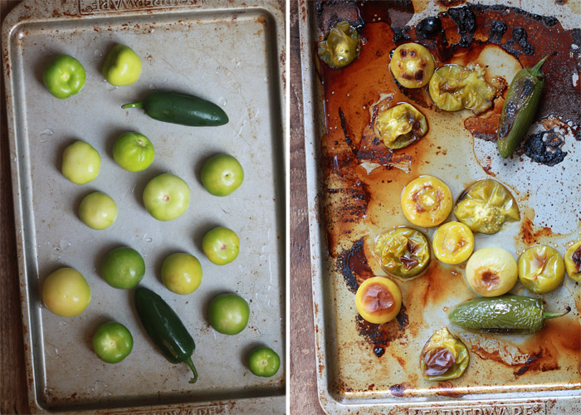

(Don’t be like me – use parchment paper or foil for easier clean-up!)

So, see all that roasty goodness up there? Peel the peppers then add everything to the soup pot, juices and all, and puree it all together with an immersion blender.

Hold up! Can we just talk about [immersion blenders](http://www.amazon.com/gp/product/B00ARQVM5O/ref=as_li_tl?ie=UTF8&camp=1789&creative=390957&creativeASIN=B00ARQVM5O&linkCode=as2&tag=kitctrea-20&linkId=ABM7QWVMJEOSUBCI) for a moment? If you don’t have one in your life, allow me to be pushy for a moment and say this: YOU NEED ONE! For everything from soups to sauces to super-smooth [pizza sauce](http://www.kitchentreaty.com/our-very-favorite-homemade-pizza-sauce/) (there’s always one person who’s opposed to chunks!) – these things are one of the best bangs for your buck, small-appliance-wise.  When you can just whip that soup into submission right in the pot, the clean-up – and therefore life – is so much easier. And then you can focus on the eating!



Anyway! After pureeing the dickens out of it all, now it’s just a matter of adding some hearty white beans and then topping with a couple little extras, if you like. You can also add some shredded chicken to all or half if the meat-inclined are interested. Because we’re all about [multivorous living](http://www.kitchentreaty.com/category/multivore-life/" \t "_blank) around here.



Multivorous. Mull-tiv-ver-us. That’s totally a word, isn’t it?

Top with a generous squeeze of lime and lots of cilantro, if you’re up for it. And a squeeze of Greek yogurt or sour cream to cool a bit of the heat, if you desire. (I got these new squeeze bottles and felt all fancy squeezing the sour cream on in a spiral, even though they’re a mess. Food art: not my forte.)

The moral of the story: Got tomatillos? Make this!

[PRINT RECIPE](http://www.kitchentreaty.com/spicy-chili-verde-with-white-beans-optional-chicken/print/)

Spicy Chili Verde with White Beans & Optional Chicken

A thick and hearty vegetarian chili verde with a good kick of heat and the zingy tang of fresh-roasted tomatillos. It's plenty satisfying on its own, but you can also add cooked and shredded chicken (we use store-bought rotisserie chicken) for the carnivores.

*yield:* 4-6 SERVINGS

*prep time:* 10 MINUTES

*cook time:* 30 MINUTES

*total time:* 40 MINUTES

INGREDIENTS:

* 1 pound tomatillos
* 2 jalapeno peppers
* 1/4 cup olive oil
* 1 medium yellow onion, diced (about 2 cups)
* 1/2 teaspoon dried oregano
* 2 medium cloves garlic, minced
* 1/2 teaspoon ground coriander
* 1/2 teaspoon salt
* A couple turns freshly ground black pepper
* 1/4 cup all-purpose flour
* 4 cups low-sodium vegetable broth\*
* 4 cups cooked small white beans (or 2 15-ounce cans, drained and rinsed)
* 1 (4-ounce) can mild diced green chiles
* 1 tablespoon freshly squeezed lime juice

GARNISHES/TOPPINGS:

* Lime wedges (for squeezing over the top)
* Cilantro leaves
* Sour cream or Greek yogurt

IF ADDING CHICKEN TO HALF:

* 1 cup cooked, shredded chicken

IF ADDING CHICKEN TO ALL:

* 2 cups cooked, shredded chicken

DIRECTIONS:

1. Preheat oven to 400 degrees Fahrenheit.
2. Remove papery husks from the tomatillos and rinse off any dirt. Place tomatillos and jalapeno peppers on a rimmed baking sheet. If you want to minimize the risk of the tomatillos exploding, score them by giving each a quick shallow slice with a knife - though I've never done this. Which is probably one of many reasons why I need to clean my oven.
3. Bake, turning tomatillos and peppers over once about 15 minutes in, until they're soft and blackened in spots, about 25 minutes. Remove from oven and allow to cool.
4. While the tomatillos and the peppers are roasting, assemble the base of the soup. To a large saucepan or medium soup pot over medium heat, add the olive oil. When heated, add the onion and oregano. Saute until soft and fragrant but not browned. Add garlic, coriander, salt, and pepper and cook, stirring, for one more minute. Add the flour and cook, stirring constantly, for three minutes. Slowly pour in the vegetable broth, stirring while you pour.
5. Bring to a boil, stirring frequently, and cook until thickened, about 15 minutes.
6. Peel jalapenos and taste the flesh. If they're very mild, you may want to add both peppers to the soup, seeds and all. On the other hand, if they're particularly hot, you may want to discard the seeds entirely and only one pepper, or even half of one pepper. Jalapenos can vary greatly in heat, so I've learned tasting and then adding cautiously is the way to go. Add the tomatillos and juices from the pan to the soup as well.
7. Remove soup from heat and, using an immersion blender or by carefully transferring to a blender in batches, puree the soup. Return to medium-low heat. Add the beans and the can of diced green chilies and stir to combine. Taste and add additional salt and pepper if desired.
8. If adding chicken to half, set a medium saucepan over medium-low heat and transfer about 3 cups of the chili to the pan. Add cooked shredded chicken and stir. Bring to a simmer then serve. If adding chicken to all, add it to the main pot now.
9. Bring to a simmer to heat the chilies and white beans. Remove from heat and stir in the lime juice.
10. Ladle into bowls and serve with cilantro leaves, additional lime wedges for squeezing over the top, and sour cream or Greek yogurt if desired.
11. Leftovers keep refrigerated in an airtight container for 2-3 days.

*\* I tend to call for low-sodium veggie broth because it allows you to better control the salt content of your soup. But if you only have plain ol' veg broth, it's cool - just start out with a little less salt to start with then adjust to taste at the end of the process.*